LAB 7
Title: Triggers
Objective:
• To be familiar with concept of Triggers and implementing it
Theory:
A trigger is a statement that the system executes automatically as a side effect of modification of database.
To design a trigger mechanism, we must meet two requirements.
✓ Specify when a trigger is to be executed. This is broken up into an event that causes the trigger to be checked and a condition that must be satisfied for trigger execution to proceed. ✓ Specify the actions to be taken when the trigger executes.
Once we enter a trigger into a database, the database system takes on the responsibility of executing it whenever the specified event occurs and the corresponding condition satisfied.
Syntax for creating triggers:
CREATE [OR REPLACE] TRIGGER trigger_name

{BEFORE | AFTER } {INSERT | UPDATE | DELETE}

ON table_name

[FOR EACH ROW]

[WHEN (condition)]

BEGIN

-- Trigger body: SQL statements or code

END;

CREATE [OR REPLACE] TRIGGER: Specifies the creation of a new trigger or replaces an existing trigger with the same name.
BEFORE | AFTER: Specifies when the trigger should be executed relative to the triggering event. A "BEFORE" trigger fires before the event, and an "AFTER" trigger fires after the event.
INSERT | UPDATE | DELETE: Indicates the event that triggers the execution of the trigger. You can specify multiple events using commas.

ON table_name: Specifies the name of the table on which the trigger is defined.
FOR EACH ROW: Indicates that the trigger should be executed once for each affected row (used for row-level triggers).
BEGIN and END: Enclose the trigger body, which contains the SQL statements or code to be executed when the trigger is fired.

Need of triggers
Triggers can be used to implement certain integrity constraints that cannot be specified using the constraint mechanism of SQL. Triggers are useful mechanisms for alerting humans or for starting certain tasks automatically when certain conditions are met.
Suppose a warehouse wishes to maintain the a minimum inventory of each item. When inventory level of an items falls below the minimum level, an order can by placed automatically. On update of the inventory level of each item, the trigger compares the current inventory level with minimum inventory level for the item, and if the level is at below new order is created.
Implementation
As we already discussed, the warehouse manages an inventory of various items. Each item has a specific inventory level and a minimum level that should be maintained. Whenever the inventory level falls below the minimum level for an item, the warehouse needs to automatically generate an order to maintain the stock.

OUTPUT:
Step 1: Create the "Items" table:
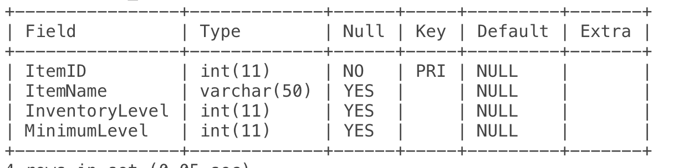
Step 2: Insert sample data:
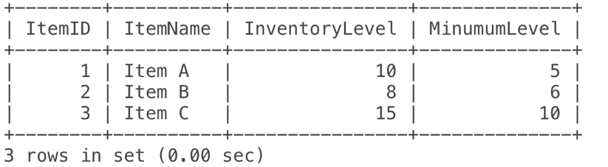

Step 3: Create the "Orders" table:
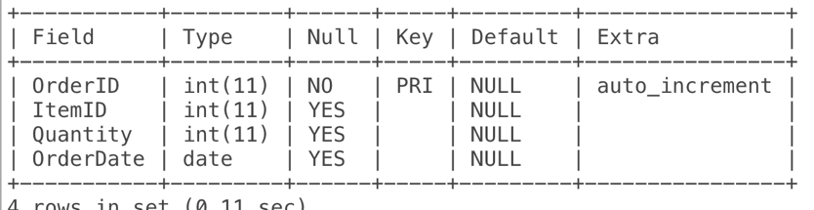
Step 4: Create the trigger:
Step 5: Update inventory levels:
Step 6: Check the "Orders" table:
